# 

# 

# 

# Computação Paralela e Distribuída

**Performance evaluation of a single core**

**Turma 2 - Grupo 9**

Ana Rita Antunes Ramada - up201904565

Luísa Maria Pereira Araújo - up201904996

Maria Sofia Diogo Figueiredo - up201904675

**Ano Letivo:** 2021/2022

# 1. Introduction

In this project, we will use the product of two matrices to study the effect on the processor performance of the memory hierarchy, when accessing large amounts of data.

For this study, three different matrix multiplication algorithms were implemented, using the C++ language, and each performance was analyzed. The first two were also implemented in Java, so that we can recognize that the performance tendency is not exclusive to C++ programs.

# 2. Algorithms Explanation

We'll discuss three matrix multiplication algorithms: the naive, line and block matrix multiplication.

It’s important to note that, for the tests made, only square matrices were used.

## 2.1 The Naive Matrix Multiplication Algorithm

for (i = 0; i < n; i++)

for (j = 0; j < n; j++)  
 for (k = 0; k < n; k++)  
 C[i,j] = C[i,j] + A[i,k] * B [k, j]  
 end for

end for  
end for

## 2.2 Line Matrix Multiplication Algorithm

|  |
| --- |
| for (i = 0; i < n; i++)  for (k = 0; k < n; k++)  for (j = 0; j < n; j++)  C[i,j] = C[i,j] + A[i,k] * B [k, j]  end for  end for end for |

## 

## 2.3 Block matrix multiplication Algorithm

for (ii = 0; ii < n; ii += blockSize)  
 for (jj = 0; jj < n; jj += blockSize)

for (kk = 0; kk < n; kk += blockSize)

for (i = 0; i < blockSize; i++)

for (k = 0; k < blockSize; k++)

for (j = 0; j < blockSize; j++)  
 C[i,j] = C[i,j] + A[i,k] * B[k,j]

end for

end for

end for  
 end for  
 end for  
end for

# 3. Performance Metrics

## 3.1 Time

Time is going to be the main factor we are going to look into when it comes to classifying each algorithm’s performance.

## 3.2 L1 DCM vs L2 DCM

Further, we are comparing how many cache misses occur with different caches: L1 DCM and L2 DCM. L1 caches are faster than L2 caches but L2 caches have a higher dimension than L1 caches.

# C - Mult and MultLine4. Speed of different algorithms in C++

The graph below shows the amount of time that the different algorithms take to execute. Here, Naive Multiplication and Line Multiplication are compared. We can conclude that Line Multiplication is significantly faster.

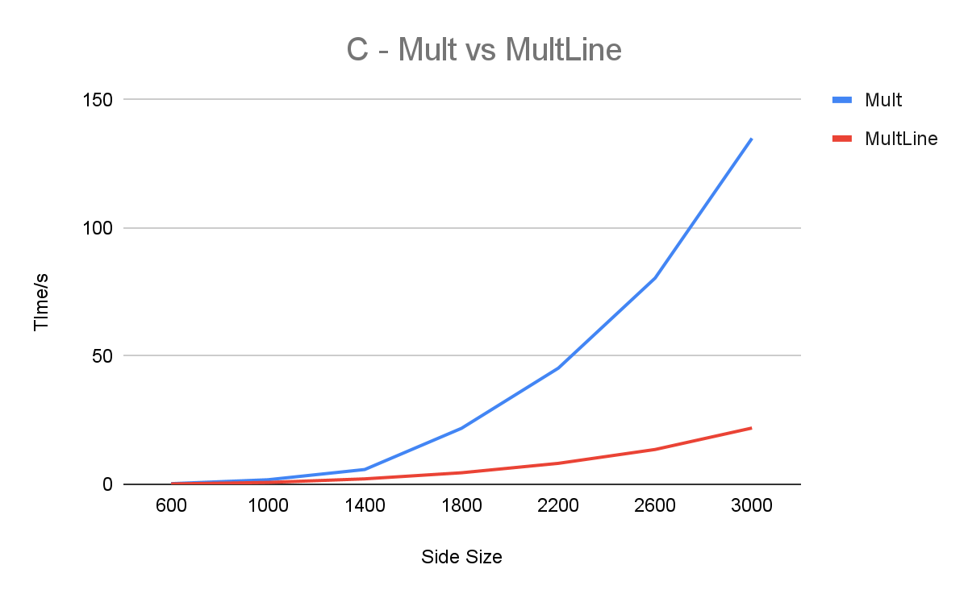The following graph shows the difference between Line Multiplication and Block Multiplication.

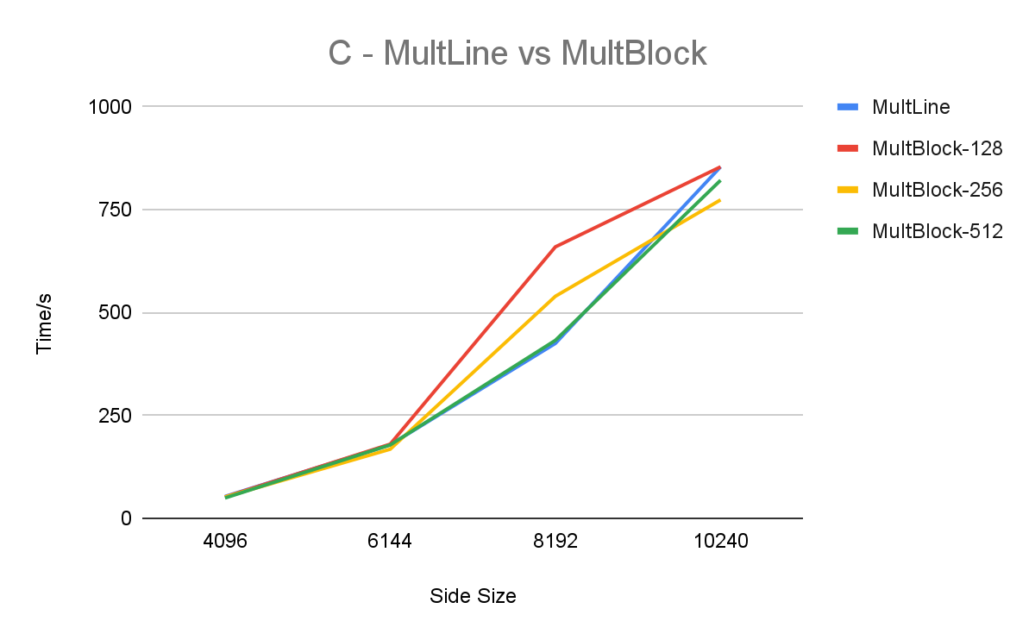

# 5. Speed of different algorithms in C++ vs Java

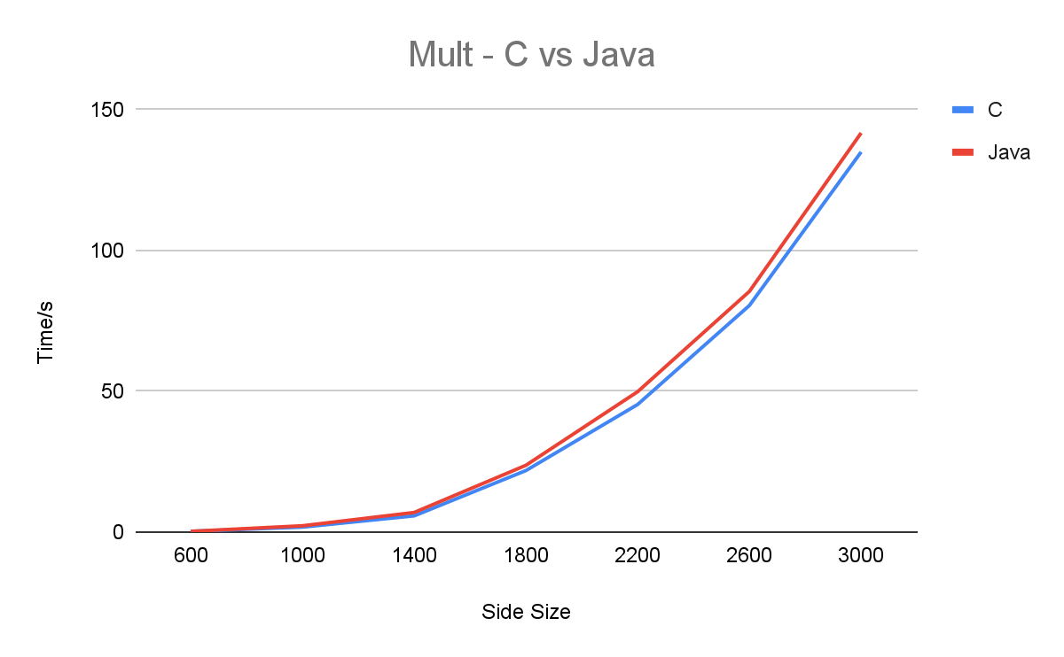Here, Naive Multiplication in C++ and Java are compared. As we can see from the graph below, C++ is slightly faster.

The following graph compares Line Multiplication in C++ vs Java. The difference in execution time increases when compared to normal Multiplication, while C++ is still faster.

# C and Java

# 6. Data Cache Misses with different algorithms

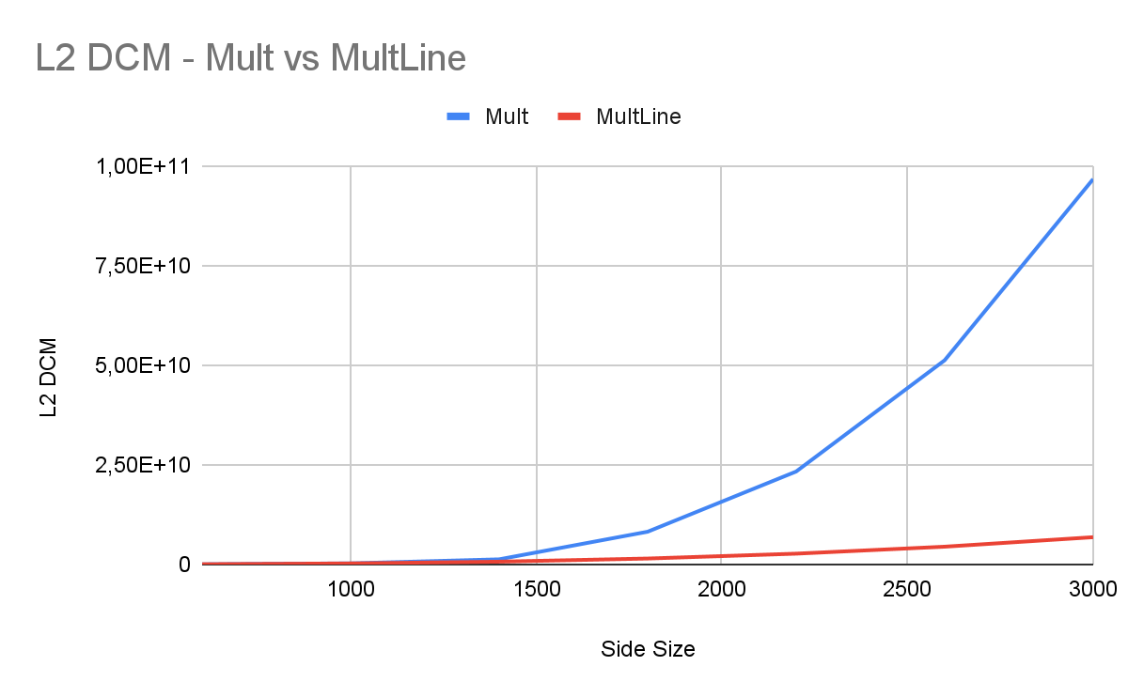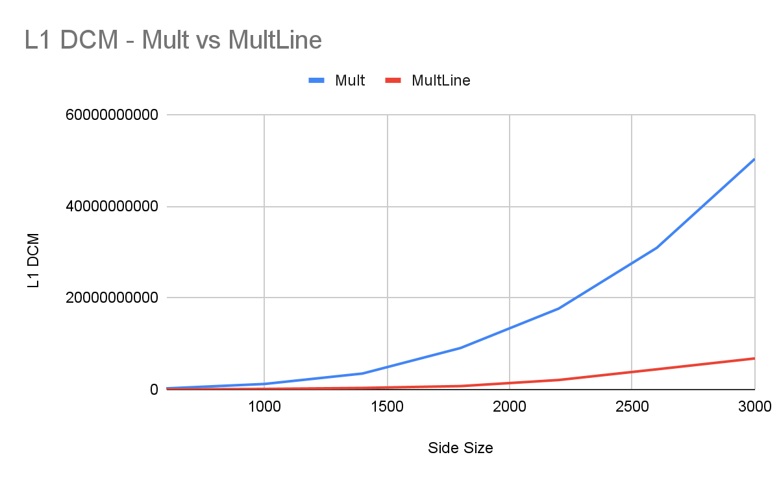In the graphs below, Naive Multiplication and Line Multiplication are compared in terms of L1 and L2 DCM, Data Cache Misses. It’s clear that Line Multiplication leads to less DCM.

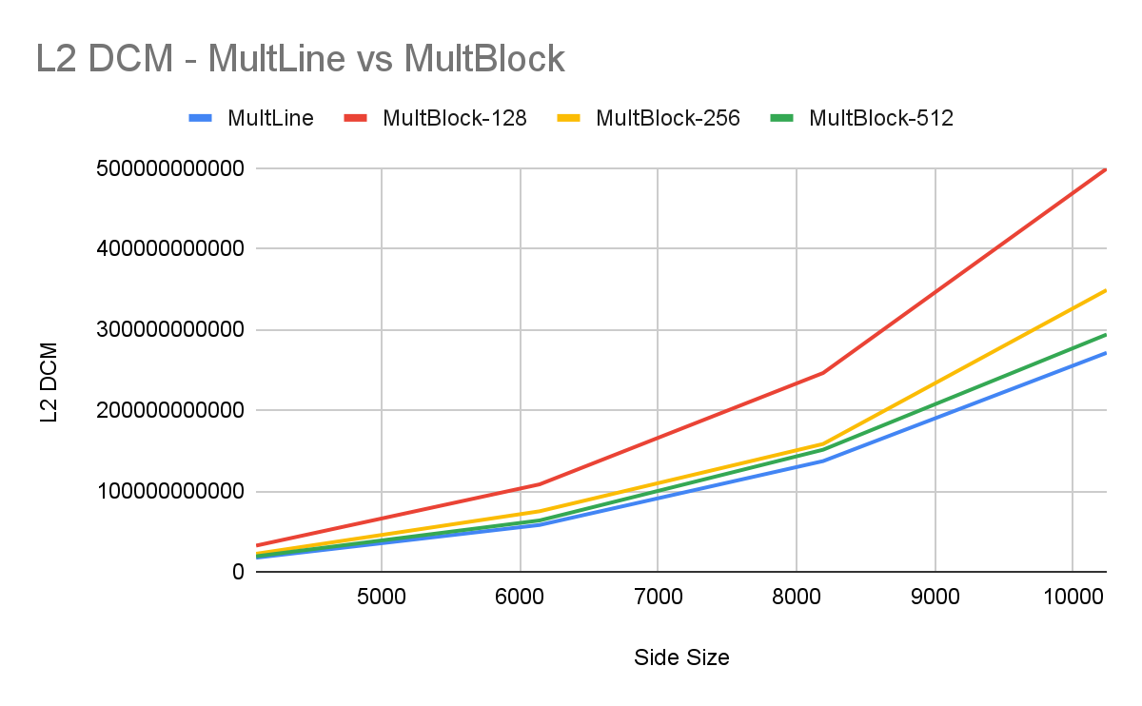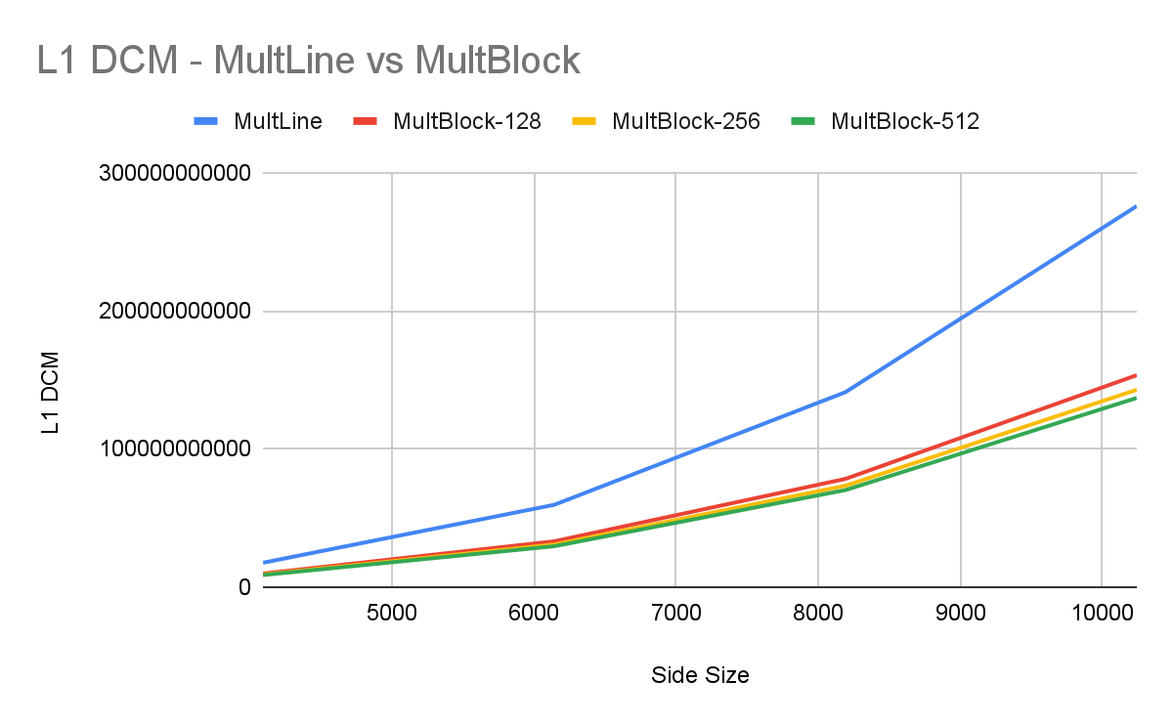In the graphs below, Line Multiplication and Block Multiplication are compared in terms of L1 and L2 DCM, Data Cache Misses. It’s clear that Block Multiplication leads to less DCM.

# 7. Conclusions

In this project, the main goal was to compare different matrix multiplication algorithms and their efficiency in different types of caches (L1 and L2), written in two different programming languages.

As expected, we obtained different results. When it comes to performance, Line Multiplication is similar to Block Multiplication, but it is much faster than Naive Multiplication.

Comparing the results obtained in C and Java, a significant difference can be noticed in the speed of both algorithms, Naive Multiplication and Line Multiplication, being faster when implemented in C.